

**Date:-** <To>

TO WHOM IT MAY CONCERN

This is certify that Mr. **<Name>** S/O **<Fname>** is employee in our organization as **<Designation>** since **<From>** to **<To>.**

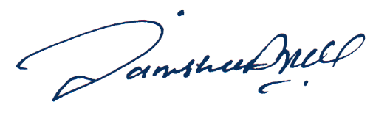We wish him success in his future endeavors.

Admin